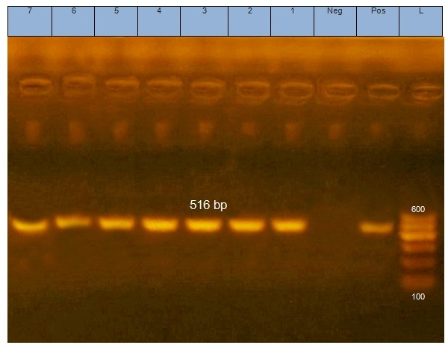
Fig. S1 Representative gel showing amplification of the blaTEM gene (516 bp) from Shigella isolates and transconjugnts. Lane L: DNA ladder (100 bp), lane Pos: positive control, lane Neg: negative control, lanes 1-7: blaTEM positive.

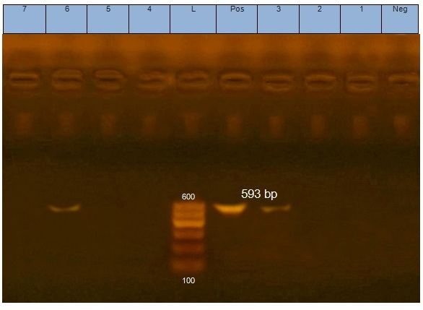
Fig. S2 Representative gel showing amplification of the blaCTX gene (593 bp) from Shigella isolates and transconjugnts. Lane L: DNA ladder (100 bp), lane Pos: positive control, lane Neg: negative control, lanes 3 and 6: blaCTX positive, lanes 1, 2, 4, 5, and 7: blaCTX negative.

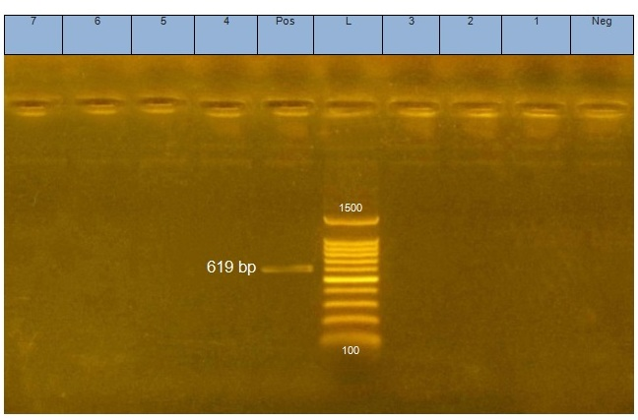
Fig. S3 Representative gel showing amplification of the blaOXA gene (619 bp) from Shigella isolates. Lane L: DNA ladder (100 bp), lane Pos: positive control, lane Neg: negative control, lanes 1-7: blaOXA negative.

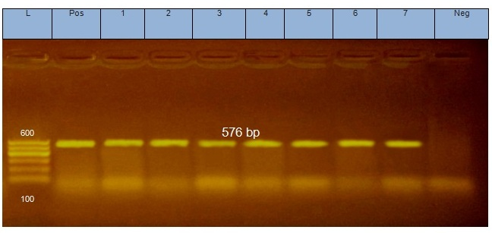
Fig. S4 Representative gel showing amplification of the tetA(A) gene (576 bp) from Shigella isolates. Lane L: DNA ladder (100 bp), lane Pos: positive control, lane Neg: negative control, lanes 1-7: tetA(A) positive.

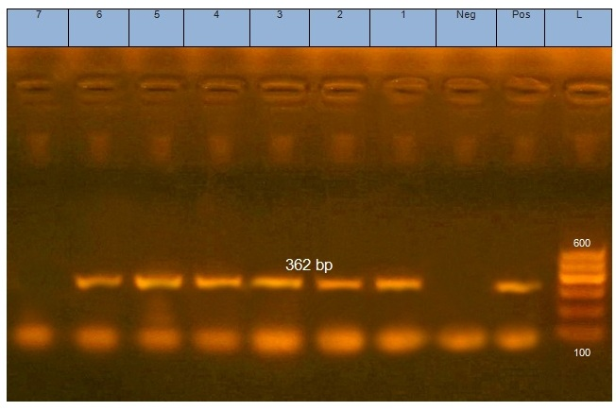
Fig. S5 Representative gel showing amplification of the qacE∆1 gene (362 bp) from Shigella isolates and transconjugnts. Lane L: DNA ladder (100 bp), lane Pos: positive control, lane Neg: negative control, lanes 1-6: qacE∆1 positive, lane 7: qacE∆1 negative.
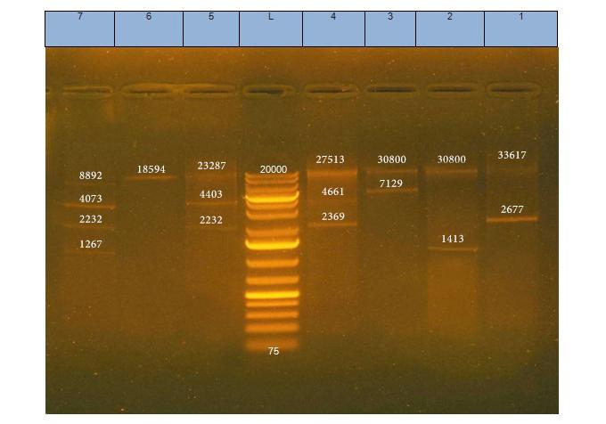
Figure S6. Plasmid profiles of 7 representative Shigella isolates in 0.8% agarose gel. Lane 1, S. dysenteriae (P4, strain 3); lane 2, S. sonnei (P7, strain 3); lane 3, S. dysenteriae (P3, strain 3); lane 4, S. dysenteriae (P2, strain 3); lane 5, S. flexneri (P6, strain 3); lane 6, S. flexneri (P5, strain 3); lane 7, S. dysenteriae (P1, strain 3) and lane L, DNA ladder (the marker).

